Practice Question-Pie Chart
The pie charts below show the comparison of different kinds of energy production in France in 1995 and 2005. Summarise the information by selecting and reporting the main features, and make comparisons where relevant. Write at least 150 words.
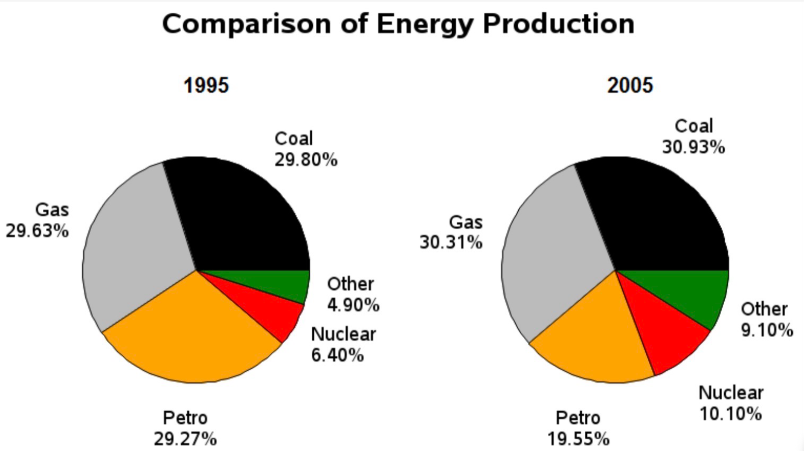

Pie Chart Sample Answer
The two pie charts illustrate the proportion of five sources of energy production (coal, gas, nuclear, petrol and other sources) in France in two years (1995 and 2005).
Overall, the share of coal, nuclear, and other energy sources increased between the two years. Among these, coal and gas remained the dominant source of energy production, while other energy sources continued to contribute the smallest share. In contrast, petroleum was the only energy source whose percentage decreased over the period.
Energy produced by coal totaled 29.80% in 1995 and by 2005, it had increased by about 1% to 30.9%. Likewise, the amount of energy generated by gas likewise went up by approximately 1% from 29.63% in the first year to 30.1% by the final year. The use of nuclear power rose significantly from 6.40% in 1995 to 10.10% in 2005. Other sources of energy production accounted for 4.90% but then climbed to 9.10%.
Petrol, on the other hand, produced 29.27% of all energy in 1995 but 10 years later only 19.55% of energy came from this source.

